Creating a Virtual Reality Environment Framework in a Game Engine as a Teaching Tool for People with Autism Spectrum Disorder

Adam Szlamp

## ABSTRACT

**Background:** For many years different studies have been done on the effectiveness of using Virtual Reality (VR) as a teaching tool for people with Autism Spectrum Disorder (ASD), many of which show significant improvement on the subject’s learning ability and cognitive social skills. Many of these studies focus on only one area of the subject which limits the scope and the Impact Factor of studies results and usability in the real world. This study is to develop a framework by using an off the shelf game engine to create the framework for researchers that are unfamiliar with games technology to assist in the creation of serious games environments that is usable for their study or as an educational tool for a client.

**Objective:** The aim of this study is to create a VR framework in the Unity game engine that is accessible enough for academic researchers that are unfamiliar with games technology, to assist in the creation of Virtual Reality Environments for people with ASD education or research. The framework needs to be 1. easy to use; 2. flexible enough to add additional content; 3. feature rich enough to allow for the creation of any scenario or environment; and 4. allows for suitable interactivity that can be recorded & tracked for research purposes.

**Methods:** The study will be carried over four months and requires researching previous academic VR studies in the field of ASD research, to find common implementations and recording methods for researching subjects with ASD. Then design the framework based on those findings, then develop the framework in Unity using both new source code and free assets from the Unity Asset Store to convert the game engine into a more user-friendly and purpose-built software for further studies. In order to determine the usability of the framework, the project will be handed to the client who is in the Senior Researcher in Digital Education for UWE Bristol.

**Results:** A number of road blocks became more and more apparent as the project was moving along. The resulting framework and positive feedback proved the premise had some promise as to the usability and simplicity of converting a off the shelf game engine into a framework for creating VR environments for educating and researching people with ASD. The short study time was not enough to fully develop the project into a fully featured framework and only resulted in the fundamental features for creating an environment and adding an interactive scenario.

**Conclusions:** Software was design but could not be implement in the time given, however this is a proof of concept that a framework can be created in a game engine and shows promising results for creating virtual environments with scenario for teaching and researching people with ASD.

## KEYWORDS

Autism Spectrum Disorder (ASD); Virtual Reality (VR); Head-mounted display (HMD); game engine; serious games; framework; education; simulation training

## Introduction

### Background

ASD is defined as a spectrum of mental disorders for neuro development that are lifelong and affect how people see, hear, and feel the world (1). VR is a method of experiencing a false simulated reality with the aid of a Head-mounted display (HMD) and an avatar in the simulation representing the user (2) .The research in using VR for ASD projects has been well covered in many academic papers and even public projects for teaching how a person with ASD experiences the world (3). There are many examples of using VR for teaching people with ASD vital life skills, such as teaching how to use the bus in a safe environment (4). Unfortunately, most of the research only focuses on one area of training or teaching; to improve the lives of people with ASD, the studies that were gathered only used the VR HMD and custom-built software with either safe virtual environments (5) or pre-recorded filmed responses (6) for that one area and as such were limited in scope for their effectiveness (7). Academic paper also explores other uses of VR technology that are related to conditions like ASD and show similar results with the limited scope (8).

### Virtual Reality

VR is separated into three main categories: non-immersive, semi-immersive, and fully immersive (9). Non-Immersive allows the user to enter the virtual environment with high resolution desktop monitor and some form of tactile interface but the user is still aware of their reality outside the simulation. Semi-Immersive is a closed environment with a large projector like IMAX and a real-world interface that replicates the one in the virtual world, the most common semi-immersive VR is professional flight simulators. Fully Immersive is an HMD with a high-resolution screen and sensors that detect the user’s real-world movements, this will be the VR of choice for this project because it’s the most common and easiest to create content for. There are a variety of HMD to pick from such as PlayStation VR (10) which is specifically designed for just playing games so is not applicable, the Google Daydream (11) which is only designed for smartphone so limits the scope for technology, lastly VIVE (12) & Oculus Rift (13) both are designed for PC and can be expanded to allow for high end research projects however VIVE is too expensive as such the option to go with Oculus Rift is the most reasonable.

### Game Engine

Game Engines are software development environments with an interface designed for artist and programmers for various roles at a standard game software company designed for creating video games and interactive software (14). Various VR software was considered like A-Frame (15) which is limited to only web development and only supports mouse and keyboard, there are also plugins to popular graphic software Maya VR (16) & Blender XR (17) both of which aren’t appropriate because of their lack of customization making them unable to be convert into a useable framework. This only allowed for the remaining two choices Unreal Engine (18) & Unity (19) which come done to how malleable the UI and features of the engine can be edited without access to the source code, Unreal unfortunately doesn’t allow for custom UI so Unity was the choice for the project.

### This Study

Developing the framework for virtual environments in a game engine to cover most areas of potential research and support VR required the usage of free assets from Unity’s assets store to get the functionality and content required on a timely basis. The framework was designed to allow the user to easily create an environment with pre-made assets with consistent functionality for the custom scenario the user wants to create for researching/testing the area of study for examining people with ASD. A major advantage to using of games technology is embracing the idea of having fun is learning in a more engaging manner (20) (21), as such the scenarios are designed to by like a checklist in an open-world action game with social interactions and daily tasks presented as challenges to gain rewards with visual/audio stimuli. The aim of this study is to create an all-purpose solution for creating VR environments with a game engine for further researching and as a teaching tool, to accomplish this the framework will be developed with support from the client who is a senior researcher of digital education for feedback on the practicality and usefulness of the framework.

## Methods

### Designing the Framework

Because of the short time available development for the project was accomplished using the waterfall model of software development (22) for designing and developing the framework in a game engine. Development started by analysing the system and software requirements, it is a reasonable assumption that the development platform would be on a mid-range PC because that is the most common setup in other VR research projects [5-6]. Each game engine put forward as a candidate had their limitations tested and it was narrowed down to software of choice Unity which came down to a handful of factors: 1. It offers a free pro license for students & educators with access to the source code (23); 2. Allows for custom UI and custom content generation; 3. The assets store for additional content is robust and is free with credit given to the original creators; 4. Has VR support built in and is easy to use. The VR HMD needed to both support both keyboards and controllers for representing the user’s hands in the virtual environment, as such Oculus Rift was chosen because it supported said features and is affordable. Afterwards the client was contacted to question on what features were required for the framework to best support both the research developer and the person with ASD using the VR kit. Finally, the framework was planned out using UML (24) to design the overall system (Figure 1) and the flowchart for the user experience (UX) (Figure 2).

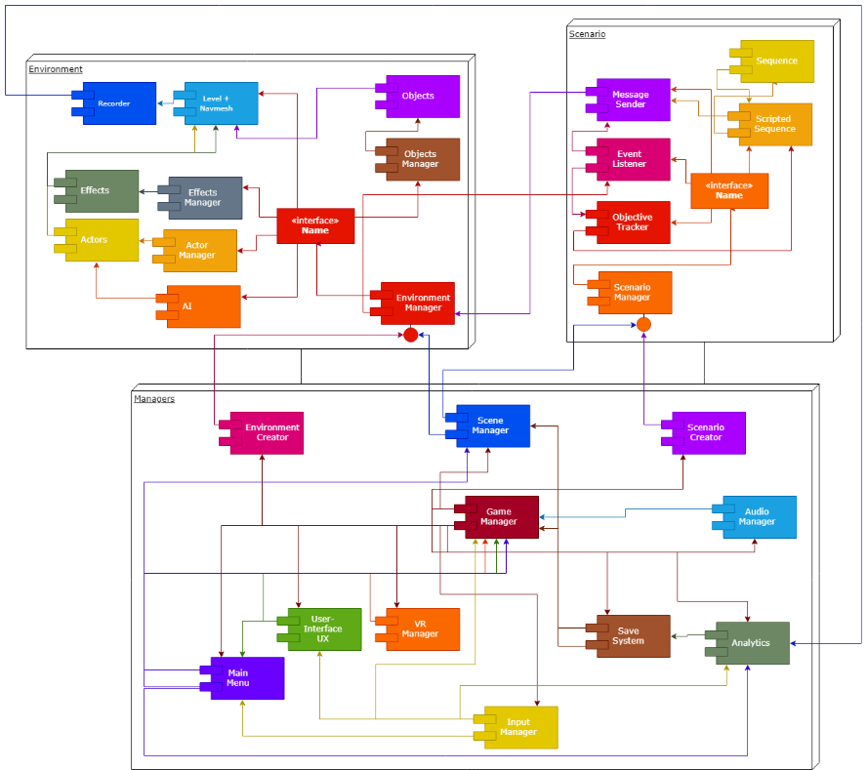

Figure . System Architecture of the Framework. Manager scripts control each system that keeps the VR and developer experience consistence.

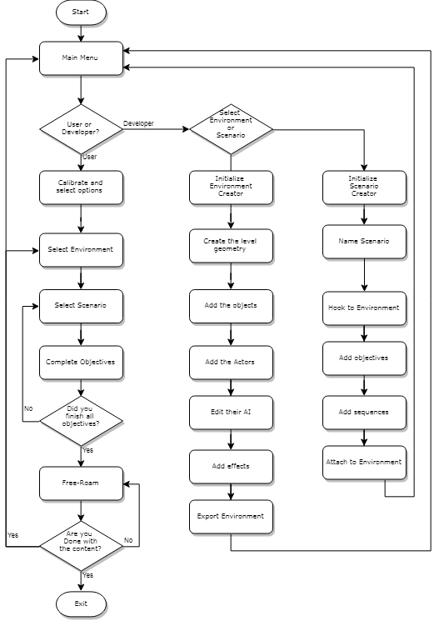

Figure Flow Diagram for the User Experience (UX).

### Creating the Framework

The framework was developed as a solo project, so the development of the framework started slowly adding in each feature one at a time each week and testing if it works. The first thing to be created was the prototype environment for testing the VR features, which at this stage was a modified version of the default VR example supplied by Unity. Once the VR system was working correctly and allowed the user to walk around and interact with objects, the project moved towards creating more environments as settings for future scenarios as a learning environment for teaching people with ASD social skills, the environments were all created with free assets from the Unity Asset Store (25) or public domain/General Public License assets from the web (26) (27).

The next task was to add human characters or NPCs to the environments for use in the scenarios that can be created later, early experiments with free assets online proved unusable because the animation and models would be too inconsistent. Unity Multipurpose Avatar (UMA) was added for its easy scripting for many different body types, clothes, sexes, and animation, this was further modified to have additional animation supplied from Mixamo animation software (28).

The final stage was adding the functionality to the framework’s managers by writing scripts that uses Unity’s UI and Editor libraries to add menu options, that give the developers tools for adding objects to a scene with scripts for audio and scenario functionally. Scenarios are built in a similar fashion to objects except they’re asset files stored in the Scenario folder. The Scenario Manager handles all the scenario’s asset files that are handled by another script to populate the environment with the NPCs and their artificial intelligence and gives functionality to the objective list for the learner and object interactions (Figure 3).

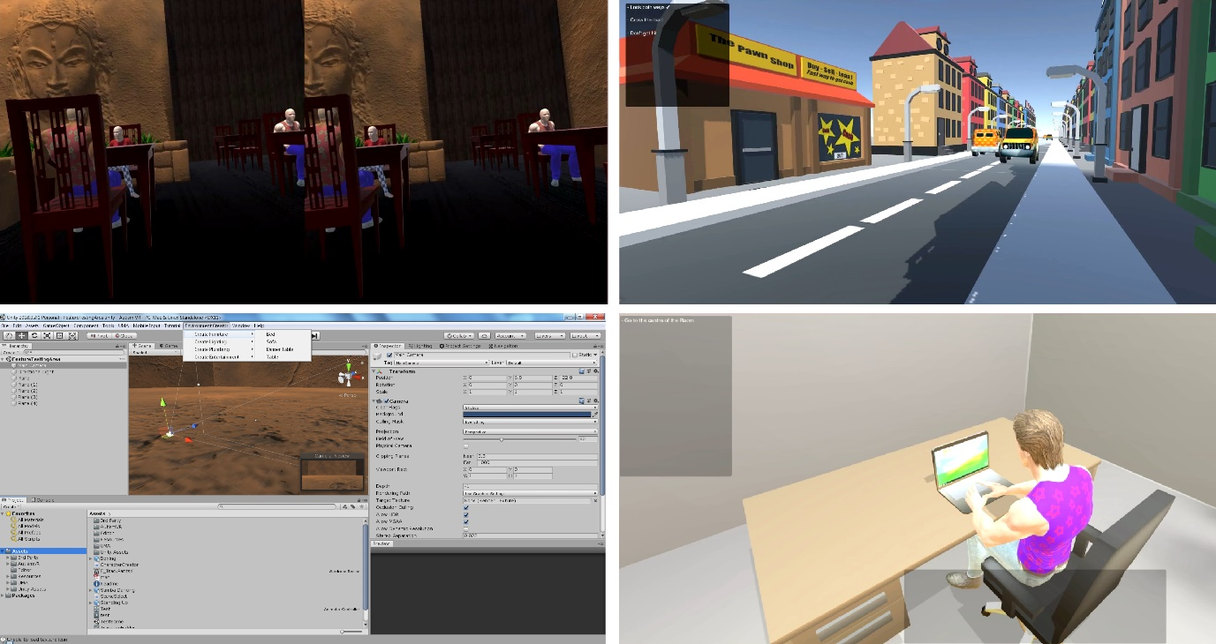

Figure Screenshots showing the in-game VR, the objective/dialogue system, and the creator menus for creating content for the VR project

### Testing

For validation of the usability and practicality of the framework, usability testing (29) was done with the client. The client was given the framework at various points throughout the project’s lifecycle and given tasks or freedom to perform tasks that would be typical for creating VR environments for teaching people with ASD, then I examined and take notes on UI or function issues that were occurring during the process. Afterwards the framework was worked on to fix or improve any issues that occurred during the usability testing or internal functional testing performed during regular coding sessions where code was added then tested in different conditions to see if issues occurred.

## Results

### Evaluate Framework

Because of the short time available most of the final product is rushed or half-finished which only shows potential and proof of concept but not actually usability in its current state. The source code is stored in a publicly accessed GitHub (30), it has both code specific for this project and code from the Unity Asset Store as such the project code is uncommented only made for a tight deadline both each script serves a single a purpose as seen in the Class Diagram (Figure 4). The code is very unsecure because it’s might to be edited for future revisions for the research developers that will need extra features for specific situations. Because of the low resource requirements of the assets/code the framework and resulting environments always run with no frame rate issues, but the physics is unrealistic along with the NPCs bumping into objects. TALK ABOUT DATA OUTPUT AFTER MADE

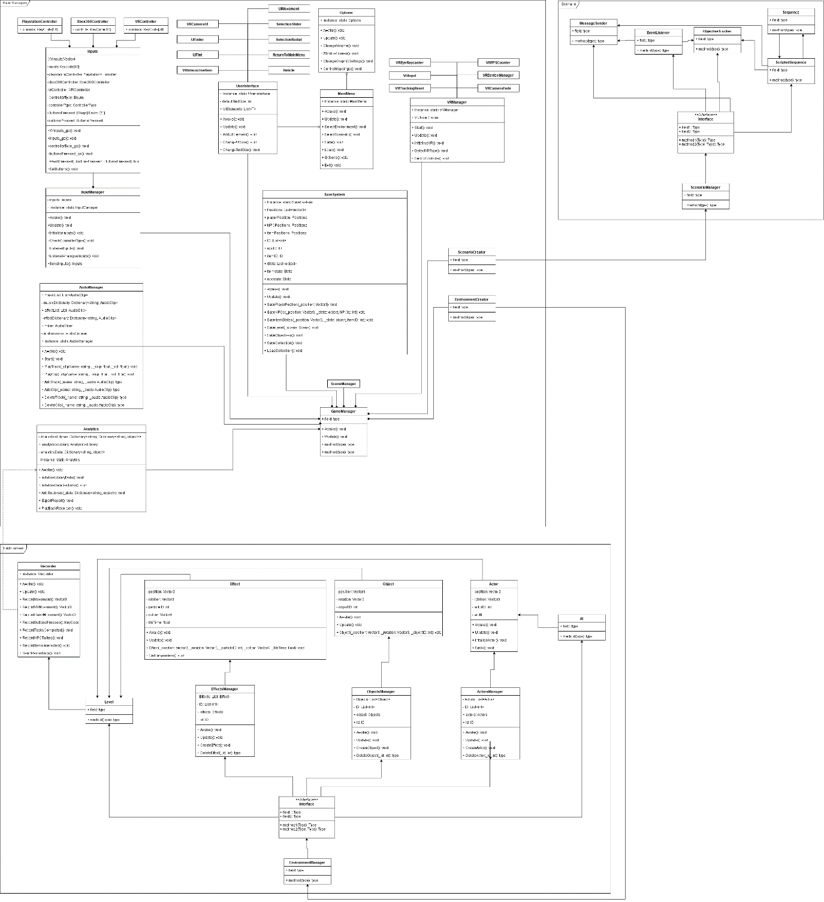

Figure Class diagram of the Unity Framework for the project

### Client Response

## Discussion

### Principal Findings

The main objective of this project was to create a framework for making VR environments in a game engine for researchers to record and gather data on people with ASD learning social skills using the VR environments. Four months is not long enough to create a framework even in something as easy to edit as Unity because the amount of content and feature testing required take to much time even for a proof of concept. This study shows possible to create a useable framework in Unity with the use of free assets from the Unity Asset Store and online recourses, however the upper limits to how far this can be pushed for creating any scenario the developers want to create couldn’t be tested so it’s an unknown. All the studies that involve using VR as a teaching tool for people with ASD show positive result and a net benefit with high impact factor (4) - (7). INSERT CLIENT RESPONSE

### Limitations

The findings should be considered under the condition that the study was conducted in short timespan and the people involved in the project were also busy with other priorities. This study only represents the opinions and experiences of the main developer and the client’s testing to determine the usefulness of the framework. The technology involved is limited only to the VR and other hardware used for development and testing. No practical testing on people with ASD has been done to show any improvement or ease of use compared to other research projects on the same subject. Therefore, more research will need to be done on using a game engine to create a framework for creating VR environments and scenarios for helping people with ASD. Finally, the development of this project only represents the four months worked on it, with more time available more features would have added to make the simulations and features more robust.

### Conclusions

In conclusion this study only shows the potential in using games technology for creating VR environments for non-game industry developers, to be used for researching and teaching people with ASD social skills and help with other life challenges. The project shows many advantages to using a game engine and especially one like Unity that allows access to the source code for educators, that developers would have a much easy time making interactive environments for research and teaching while also being malleable enough to allow the creation of a framework to make development easier for non-game industry users, rather then developing new software for VR or other research project for creating virtual environments for helping people with ASD. But the short time available to the project, the limitations to both content available to add to the framework and the limit access to technology beyond what was affordable, severely limits both the scope and scale for how far this type of research can be pushed in this study.

# References

1. **National Autistic Society. [Online] [Cited: 1 2 2019.] https://www.autism.org.uk/about/what-is/asd.aspx.**

**2. Krueger, Myron. *Artificial Reality.* Boston : Addison-Wesley, 1983. 0-201-04765-9.**

**3. *National Autistic Society.* [Online] [Cited: 01 04 2019.] https://www.autism.org.uk/get-involved/campaign/tmi/vr.aspx.**

**4. *Virtual Travel Training for Autism Spectrum Disorder: Proof-of-Concept Interventional Study.* Marco S, Miguel B, Fernando B, Miguel C-B. s.l. : JMIR Serious Games, Jan 2018, Vol. 6(1). e5.**

**5. *A Virtual Reality Training Application for Adults With Asperger’s Syndrome.* Rojo D, Mayor J, Rueda JJG, Raya L, Potel M. s.l. : IEEE Computer Graphics and Applications, 22 March 2019, Vol. 39(2). 0272-1716.**

**6. *Virtual Reality Job Interview Training in Adults with Autism Spectrum Disorder.* Smith MJ, Ginger EJ, Wright K, Wright MA, Taylor JL, Humm LB, Olsen DE, Bell MD, Fleming MF. s.l. : Journal of Autism and Developmental Disorders, 07 May 2014, Vol. 44(10). 2450-63.**

**7. *Design of a Virtual Reality Based Adaptive Response Technology for Children With Autism.* Lahiri U, Bekele E, Dohrmann E, Warren Z, Sarkar N. s.l. : IEEE Transactions on Neural Systems and Rehabilitation Engineering, 21 Jan 2013, Vol. 21(1). 55-64.**

**8. *Implementations of Virtual Reality for Anxiety-Related Disorders: Systematic Review.* Oing T, Prescott J. s.l. : JMIR Serious Games, 7 Nov 2018, Vol. 6(4). e10965.**

**9. *Health and Safety Issues associated with Virtual Reality - A Review of Current Literature.* Costello P, July Rd, Costello P. Loughborough : Loughborough University, 1997.**

**10. PlayStation VR | The VR gaming system for PS4 | PlayStation. *Offical Playstation.* [Online] Sony. [Cited: 01 02 2019.] https://www.playstation.com/en-gb/explore/playstation-vr/.**

**11. *Daydream.* [Online] Google. [Cited: 01 02 2019.] https://vr.google.com/daydream/.**

**12. VIVE™ | Discover Virtual Reality Beyond Imagination. *VIVE.* [Online] HTC. [Cited: 01 02 2019.] https://www.vive.com/uk/.**

**13. Oculus Rift: VR Headset for VR Ready PCs | Oculus. *Oculus.* [Online] Facebook. [Cited: 01 02 2019.] https://www.oculus.com/rift/.**

**14. J, Ward. What is a Game Engine?- GameCareerGuide.com. *Game Career Guide.* [Online] informa tech. [Cited: 01 02 2019.] http://www.gamecareerguide.com/features/529/what_is_a_game.php.**

**15. Diego M, Don McD, Kevin N. A-Frame – Make WebVR. *A-Frame.* [Online] [Cited: 01 02 2019.] https://aframe.io.**

**16. VR-Plugin - Create Virtual Reality with Autodesk Maya. *VR-Plugin.* [Online] Autodesk, Inc. [Cited: 01 02 2019.] https://vr-plugin.com/.**

**17. Blender XR - MARUI-Plugin. *Blender XR.* [Online] Blender Foundation. [Cited: 01 02 2019.] https://www.marui-plugin.com/blender-xr/.**

**18. VR / AR. *Unreal Engine.* [Online] Epic Games. [Cited: 01 02 2019.] https://www.unrealengine.com/en-US/vr.**

**19. Unity - Manual: VR overview. *Unity.* [Online] Unity Technologies. [Cited: 01 02 2019.] https://docs.unity3d.com/Manual/VROverview.html.**

**20. Koster, R. *A Theory of Fun for Game Design.* s.l. : Paraglyph Press, 2004. 1932111972.**

**21. J, Huizinga. *Homo Ludens: A Study of the Play-Element in Culture.* s.l. : Angelico Press, 2016. 1621389995.**

**22. *Managing the Development of Large Software Systems.* Royce, W.W. s.l. : Proceedings of IEEE WESCON, 1970, Vol. 26. 328-388.**

**23. Unity for Education | Unity. *Unity.* [Online] Unity Technologies. [Cited: 01 02 2019.] https://unity.com/education.**

**24. UML basics: An introduction to the Unified Modeling Language. *IBM Developer.* [Online] IBM. [Cited: 01 02 2019.] https://www.ibm.com/developerworks/rational/library/769.html.**

**25. Unity Asset Store - The Best Assets for Game Making. *Unity Asset Store.* [Online] Unity Technologies. [Cited: 01 02 2019.] https://assetstore.unity.com/.**

**26. 3D Models for Free - Free3D.com. *Free3D.* [Online] Free3D. [Cited: 01 02 2019.] https://free3d.com/.**

**27. Free 3D Models, Download or Edit Online · Clara.io. *Clara.io.* [Online] Exocortex Technologies, Inc. [Cited: 01 02 2019.] https://clara.io/library.**

**28. Mixamo. *Mixamo.* [Online] Adobe. [Cited: 01 02 2019.] https://www.mixamo.com/#/?page=1&type=Motion%2CMotionPack.**

**29. Isbister K, Schaffer N. *Game Usability: Advancing the Player Experience.* s.l. : CRC Press, 2008. 0123744474.**

**30. A, Szlamp. AnimeAdam/AutismVR-GRD. *GitHub.* [Online] GitHub, Inc. [Cited: 16 03 2019.] https://github.com/AnimeAdam/AutismVR-GRD.**